Let us define an equation in EQN which has complex and real roots, X^5 – X + 1 = 0
Enter it into the EQN editor, by f EQN: [NEW] x [F2] g[5] g[-] x g[+] g[1] ENTER [Solver]
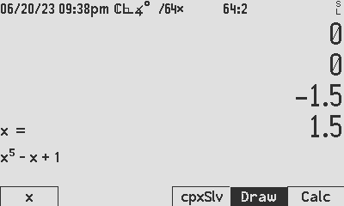
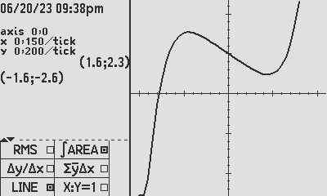
Now, define x by pressing [x] then
define the lower limit 1.5 [CHS] [x] then
define the higher limit 1.5 [x]
[DRAW]

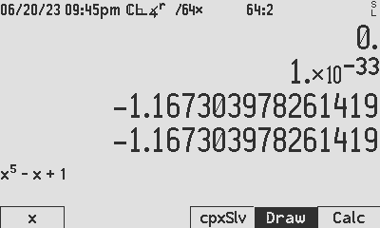
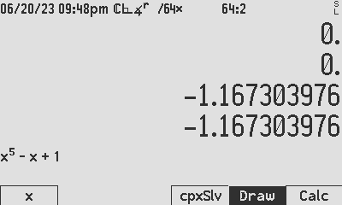
The lower left point on the Cartesian plane is given in the left parenthesis (-1.6, -2.5) and the upper right point is given by the other set of parenthesis, (1.6,2.3).
SDIGS = 10
SDIGS = 34
Now it is clear to see that there is only 1 real root, and looking at the grading marks on the axis which are 0.150 apart, and the left extreme of X=-1.6, the root seems to be around -8 x 0.15 = -1.2, definitely between -1.35 and -1.05.
To find the real root, you can use either the real or complex solver as follows:
Complex root finder, using the default accuracy, for the real root: 1.35 [CHS] [x] 1.05 [CHS] [x] [cpxSlv], resulting in -1.1673… with a uncertainty of 1E-33. This may take a while on battery power, so it is possible to reduce accuracy by setting in MODE menu, SDIGS to 10 digits. Repeating the solve now produces the same root to 10 digits, with possible courser uncertainty.

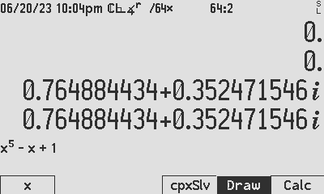
The same way you solve for the complex root. Start with the estimates, say 1.0 and 2.0 and search. In this case it found a root at 0.765 + 0.352i. A quick test proves that the complex conjugate is also a root.
SDIGS = 10
Experimenting with more starting points provides -0.181 + 1.083i and the quick CALC test shows it conjugate is also the last missing root.

Using the standard HP solver way: 1.5 [CHS] [x] 0.8 [CHS] [x] [x] provides the same real root as previously found:
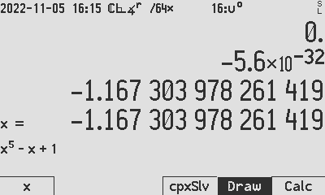

Author Jaco Mostert
Copyright (C) 2023 The C47 Development Team. Permission is granted to copy, distribute and/or modify this document under the terms of the GNU Free Documentation License, Version 1.3 or any later version published by the Free Software Foundation; with no Invariant Sections, no Front-Cover Texts, and no Back-Cover Texts. A copy of the license can be downloaded from gnu.org.

